📚 2.3 List Implementations (Deep Internal Working)
We’ll cover:
- ArrayList
- LinkedList
- Vector
- Stack
And understand:
- Internal structure
- Memory model
- Time complexity
- Real use cases
- When NOT to use

1️⃣ ArrayList (Most Important)
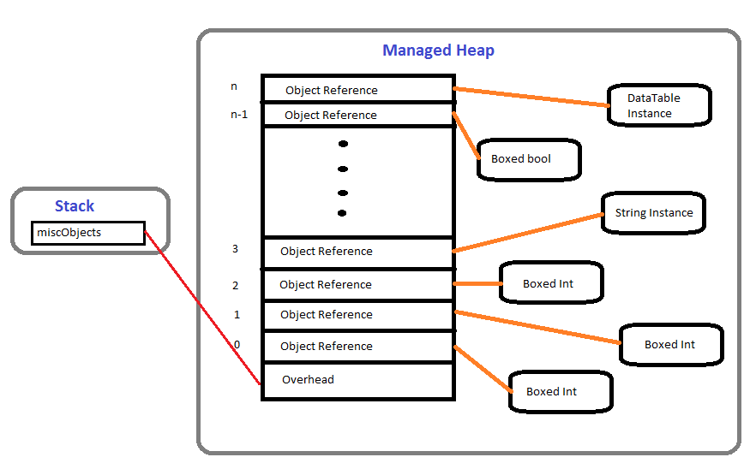
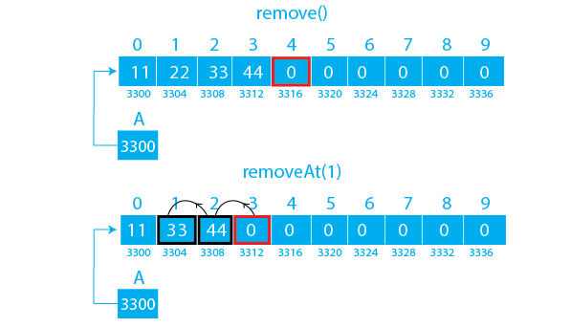
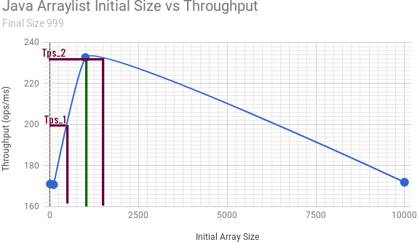
4

🔷 Internal Structure
transient Object[] elementData;
private int size;
It is literally a resizable array.

🔥 How It Grows
Default capacity = 10
When full:
newCapacity = oldCapacity + (oldCapacity / 2);
So growth = 50%
Example:
10 → 15 → 22 → 33 → 49 ...

🔥 Add Operation
list.add(x);
Steps:
- Check if array full
- Resize if needed
- Insert element
- Increase size
Time complexity:
- Normal add → O(1)
- Resize add → O(n)
- Amortized → O(1)

🔥 Get Operation
list.get(index);
Direct array access:
elementData[index]
Time complexity:
O(1)
Very fast.

🔥 Remove Operation
If removing from middle:
- Shift elements left
- Reduce size
Time complexity:
O(n)

🔥 When to Use
- Frequent reads
- Less insert/delete in middle
- Random access needed

2️⃣ LinkedList
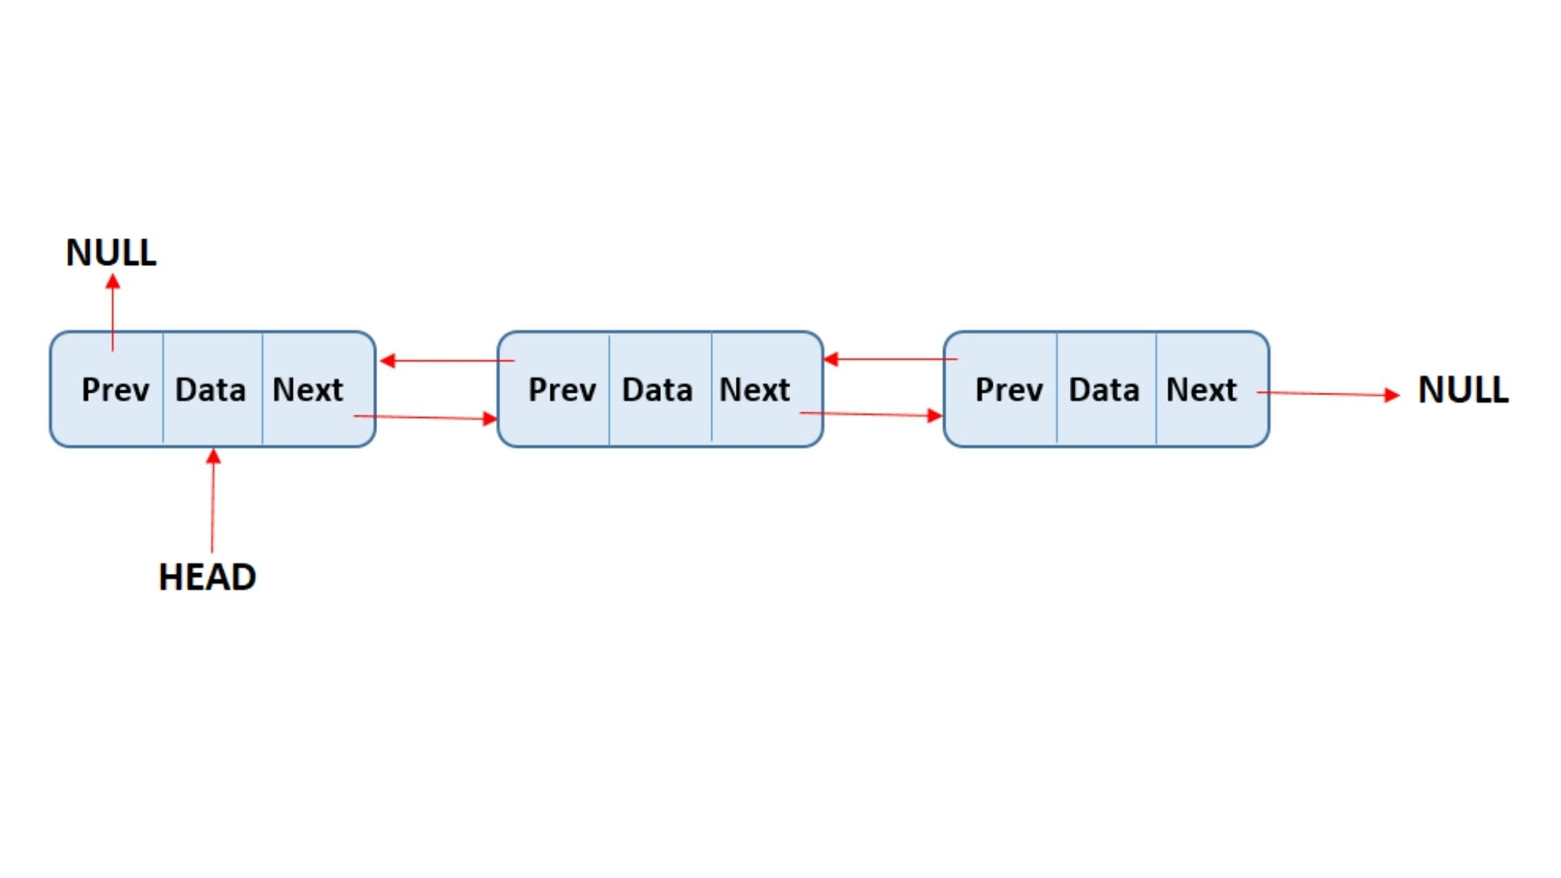
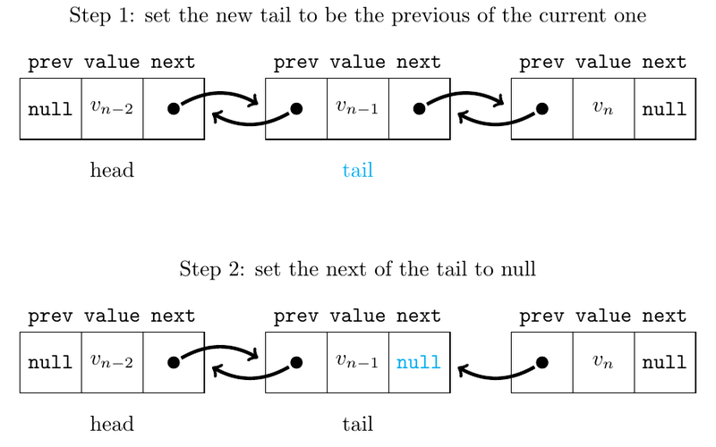
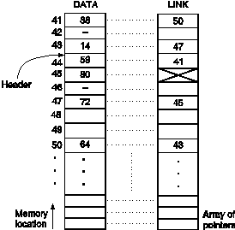
4

🔷 Internal Structure
It is a Doubly Linked List
Each node contains:
class Node<E> {
E item;
Node<E> next;
Node<E> prev;
}

🔥 Add Operation
If adding at end:
- Update last node
- Link new node
Time complexity:
O(1)
If adding in middle:
O(n) (to traverse)

🔥 Get Operation
list.get(index);
Must traverse from start or end.
Time complexity:
O(n)
Slower than ArrayList.

🔥 Memory
LinkedList uses:
- Data
- 2 pointers per node
So memory heavy.
Also cache-unfriendly.

🔥 When to Use
- Frequent insert/delete at beginning or middle
- Queue/Deque operations

3️⃣ Vector
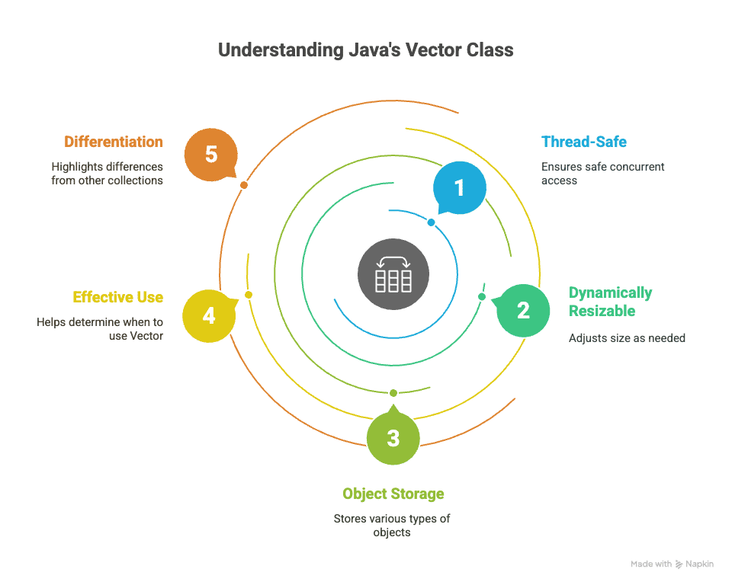
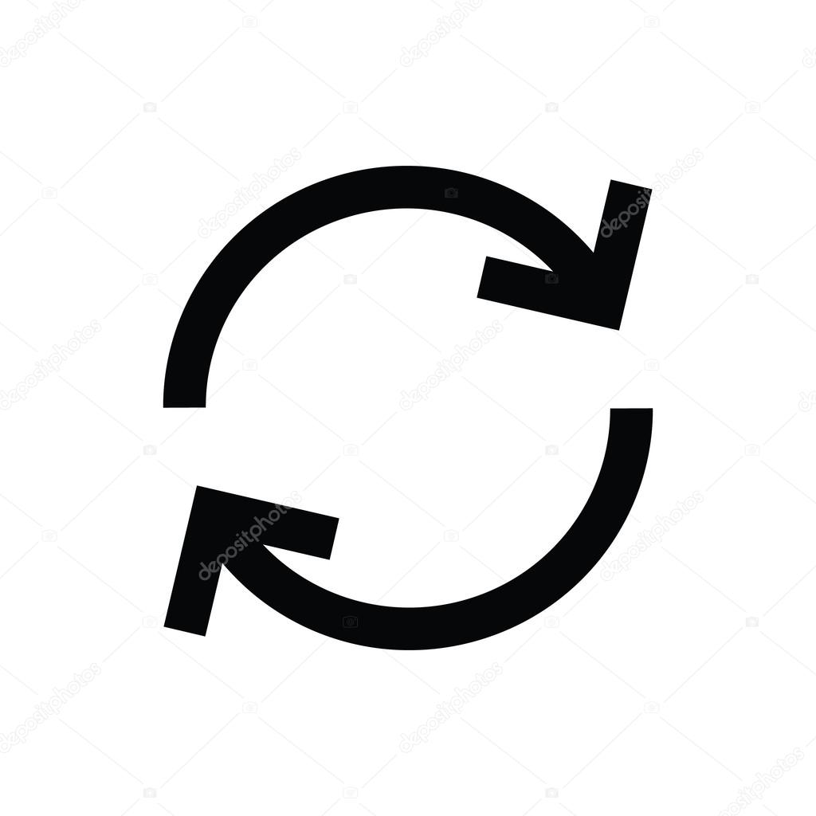
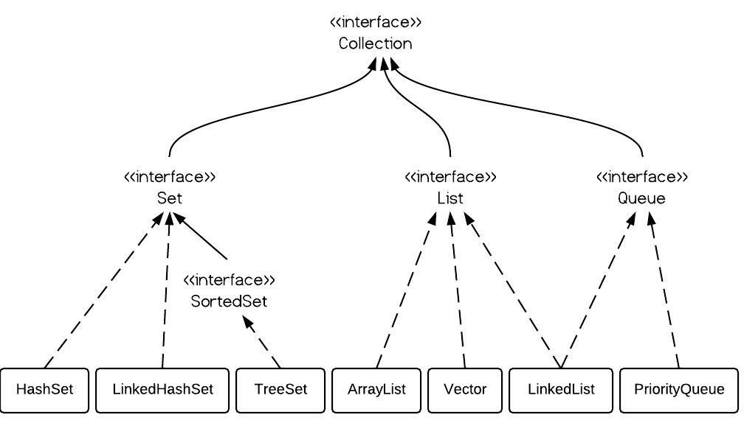
4

🔷 Internal Structure
Same as ArrayList:
- Dynamic array
But difference:
All methods are synchronized.

🔥 What Does That Mean?
public synchronized boolean add(E e)
Thread-safe but slower.

🔥 Growth Strategy
Vector doubles capacity by default:
newCapacity = oldCapacity * 2
Unless specified.

🔥 Why Rarely Used?
- Legacy class
- Slow due to synchronization
- Use Collections.synchronizedList() instead

4️⃣ Stack
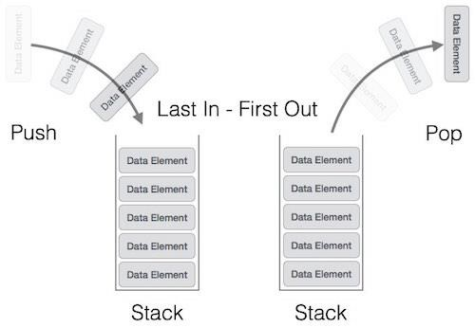
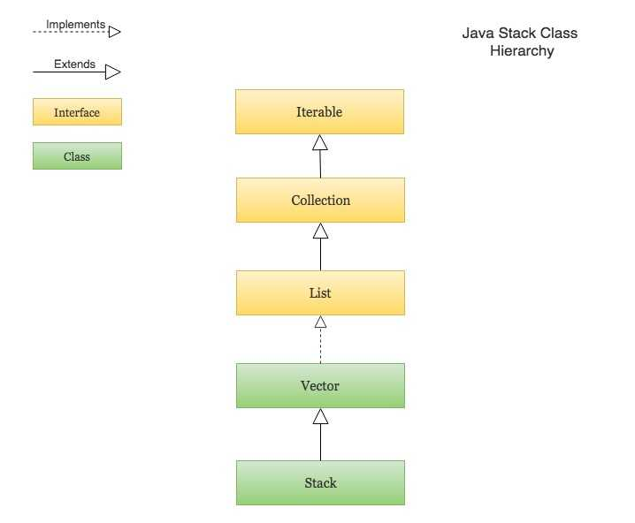
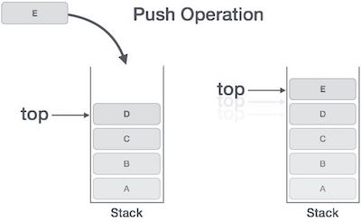
4

🔷 Internal Structure
Stack extends Vector:
public class Stack<E> extends Vector<E>
So:
- Thread-safe
- Uses dynamic array internally

🔥 Operations
push()
pop()
peek()
LIFO → Last In First Out

🔥 Why Not Recommended?
Modern Java prefers:
Deque<E> stack = new ArrayDeque<>();
Better performance.
Stack is considered legacy.

📊 Full Comparison Table
Feature | ArrayList | LinkedList | Vector | Stack
Internal DS | Dynamic Array | Doubly Linked List | Dynamic Array | Vector
Get | O(1) | O(n) | O(1) | O(1)
Add End | O(1) | O(1) | O(1) | O(1)
Add Middle | O(n) | O(n) | O(n) | O(n)
Thread Safe | ❌ | ❌ | ✅ | ✅
Memory | Low | High | Low | Low
Modern Use | ✅ | Limited | ❌ | ❌

🧠 Interview Insight Questions
Why is LinkedList slower than ArrayList for reading?
→ No direct index access.
Why is Vector slower?
→ Synchronization overhead.
Why is ArrayDeque preferred over Stack?
→ Non-legacy + better performance.

🎯 Real Backend Advice
In 90% of cases:
List<T> list = new ArrayList<>();
Is correct choice.
LinkedList is rarely optimal unless you truly need heavy insert/delete.

